Employee Compensation Application Screen shots:

User Story1 Application Screenshots:

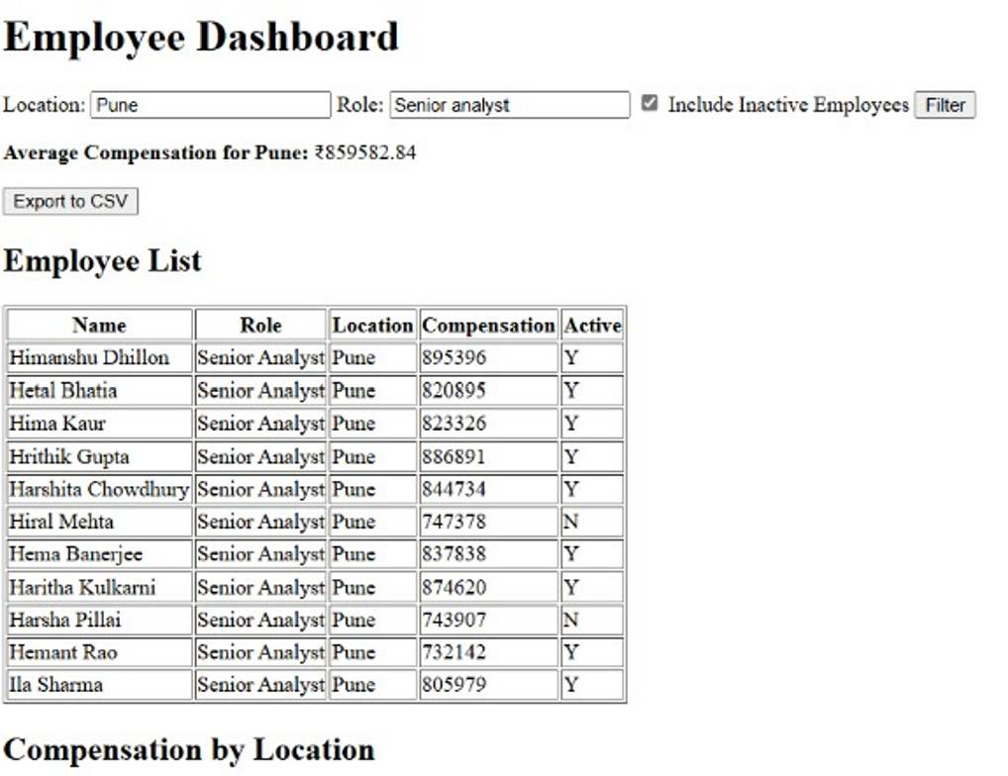

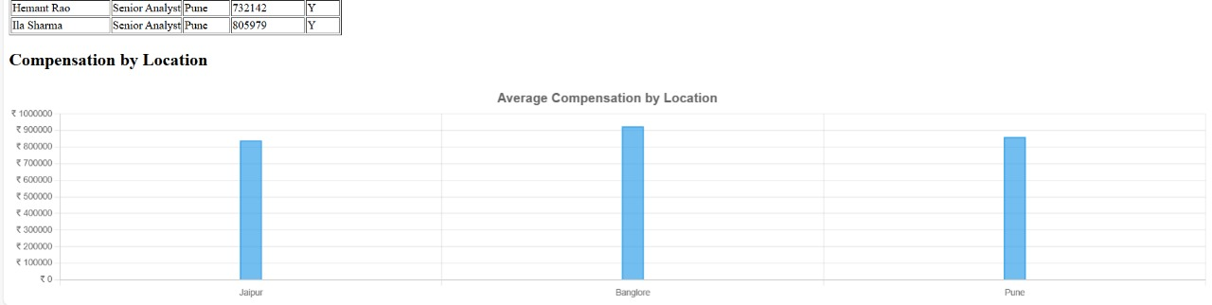

**User Story2 Application Screenshot.**

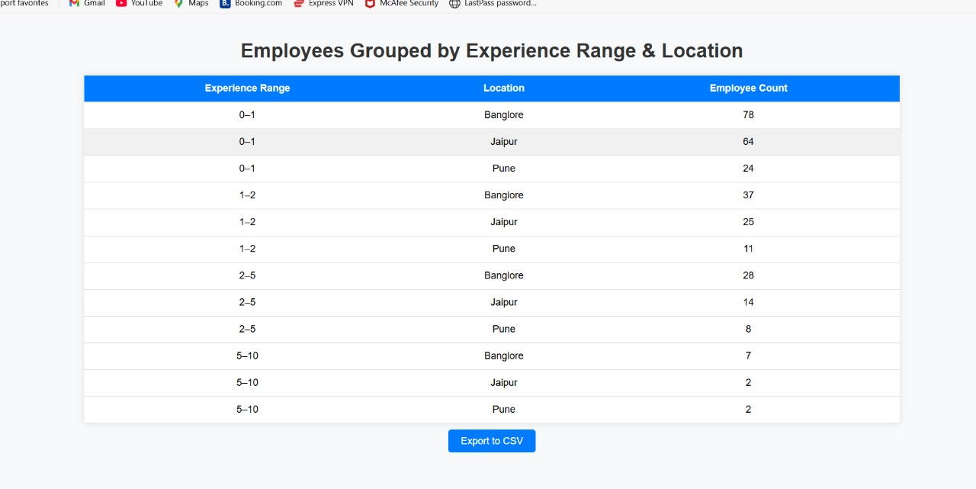

**User Story 3 to simulate Compensation Increament:**

